# Lab 7 Assignment

## Question 1

Determine what this Javascript code will print out.

**Code**

x = 1;

var a = 5;

var b = 10;

var c = function( a, b, c) {

    document.write(x);

    document.write(a);

    var f = function(a, b, c){

        b = a;

        document.write(b);

        b = c;

        var x = 5;

    }

    f(a,b,c);

    document.write(b);

    var x = 10;

}

c(8,9,10);

document.write(b);

document.write(x);

**Output**

Undefined

8

8

9

10

1

## Question 2

**Define Global scope and Local Scope in javascript.**

Any variable declared outside of a function belongs to the global scope, and it is accessible anywhere in your code.

Each function has its own scope, and any variable declared within that function is only accessible from that function and any nested functions.**This is known as local scope** .

## Question 3

**A: No**

**B: Yes**

**C: No**

**D: Yes**

**E:Yes**

**Reason**: Variable is accessible in its scope and its nested scopes. But not accessible in its parent scopes and global scope.

## Question 4

The Output will be:

**81**

**25**

## Question 5

**Result**

10 will show in pop up dialog.

Var foo=1;

function bar(){

if(!foo){

var foo = 10;

}

alert(foo);

}

## 

## 

## Question 6

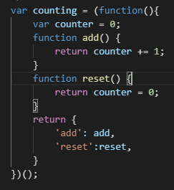

## Question 7

-The free variable is **counter.**

-Free variables are variables that are declared outside a function scope (neither local nor parameters)and are used within the function scope.

## Question 8

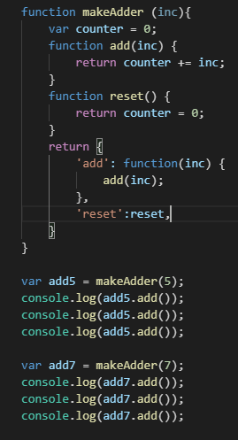

## Question 9

By using IIFE pattern you can wrap all javascript code as a module keep global namespace clean.

## Question 10

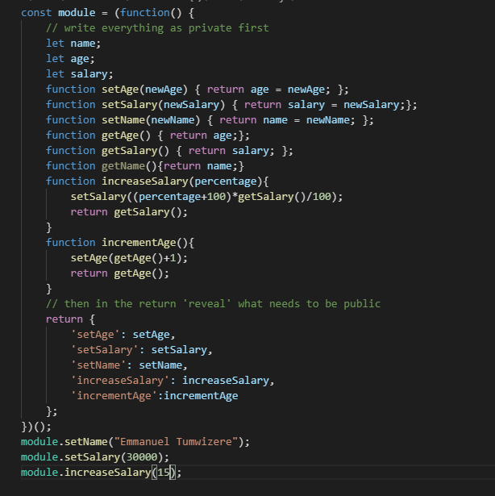

## Question 11

